***COMPLEX CIRCUIT ANALYSIS USING BREADBOARD***

***(OPEN ENDED LAB)***

**LAB # 08**



**Spring 2023**

**CSE-103L Circuit and Systems-I Lab**

Submitted by: **Jamal khan**

Registration No: **22PWCSE2203**

Class Section: **B**

“On my honor, as student of University Of Engineering And Technology, I have

Neither given nor received unauthorized assistance on this academic work.”

Submitted to:

**Engr. Dr. Muniba Ashfaq**

May 28 , 2023

Department of Computer Systems Engineerig

University of Engineering and Technology, Peshawar ***OBJECTIVES:***

*In this lab, we study how to analyze the complex circuit and how to apply KCL, KVL & OHM’S law on complex circuit to solve the complex circuit.*

***EQUIPMENTS:***

1. *Breadboard.*
2. *Different resistors.*
3. *Connecting wires.*
4. *Power supply.*

***THEORY:***

*In this lab, we study about three laws KCL, KVL and OHM’s law in a complex circuit.*

* ***KIRCHOFF’S VOLTAGE LAW:***

***Gustav Kirchhoff’s Voltage Law*** *is the second of his fundamental laws we can use for circuit analysis. His voltage law states that for a closed loop series path* ***the algebraic sum of all the voltages around any closed loop in a circuit is equal to zero****. This is because a circuit loop is a closed conducting path, so no energy is lost.*

*In other words, the algebraic sum of ALL the potential differences around the loop must be equal to zero as: ΣV = 0****.*** *Note here that the term “algebraic sum” means to consider the polarities and signs of the sources and voltage drops around the loop.*

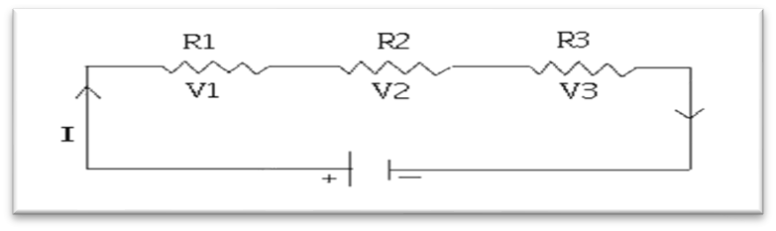

* ***MATHEMATICAL EXPRESSION:***

*In the above circuit R1, R2 and R3 are three resistors connected in series across a voltage source V. V1, V2 and V3 are voltage drops across resistors R1, R2 and R3 respectively. So according to Kirchoff voltage law:*

*V+(-V1)+(-V2)+(-V3)=0*

*V-V1-V2-V3=0*

*V=V1+V2+V3*

*This is called KVL equation.*

*V=V1+V2+V3*

*Applied voltage = sum of all voltage drops Or*

*The source voltage is equal to the sum of all voltage drops.*

* ***KIRCHOFF’S CURRENT LAW:***

***Gustav Kirchhoff’s Current Law*** *is one of the fundamental laws used for circuit analysis. His current law states that for a parallel path* ***the total current entering a circuits junction is exactly equal to the total current leaving the same junction****. This is because it has no other place to go as no charge is lost.*

*In other words, the algebraic sum of ALL the currents entering and leaving a junction must be equal to zero as: Σ IIN = Σ IOUT.*

* ***MATHEMATICAL EXPRESSION:***

***A Single Junction***

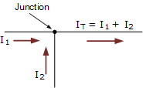*Here in this simple single junction example, the current IT leaving the junction is the algebraic sum of the two currents, I1and I2 entering the same junction. That is IT = I1 + I2.*

*Note that we could also write this correctly as the algebraic sum of IT - (I1 + I2) = 0.*

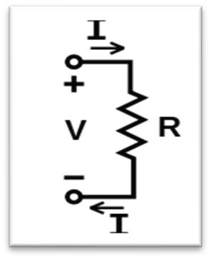

➢ ***OHM’S LAW:***

***Ohm's law*** *states that the* [*current*](https://en.wikipedia.org/wiki/Electric_current) *through a* [*conductor*](https://en.wikipedia.org/wiki/Electrical_conductor) *between two points is directly* [*proportional*](https://en.wikipedia.org/wiki/Proportionality_(mathematics)) *to the* [*voltage*](https://en.wikipedia.org/wiki/Voltage) *across the two points. Introducing the constant of proportionality, the* [*resistance,*](https://en.wikipedia.org/wiki/Electrical_resistance) *one arrives at the usual* ***mathematical equation*** *that describes this relationship:*  𝑽

# =

𝑹

*where I is the current through the conductor in units of* [*amperes,*](https://en.wikipedia.org/wiki/Ampere) *V is the*

*voltage measured across the conductor in units of* [*volts,*](https://en.wikipedia.org/wiki/Volt) *and R is the* [*resistance*](https://en.wikipedia.org/wiki/Electrical_resistance) *of the conductor in units of* [*ohms.*](https://en.wikipedia.org/wiki/Ohm) *More specifically, Ohm's law states that the R in this relation is constant, independent of the current.*

➢ ***RESISTANCE:***

*Resistance is the opposition that a substance offers to the flow of electric* [*current.*](https://whatis.techtarget.com/definition/current) *It is represented by the uppercase letter R. The standard unit of resistance is the* [*ohm,*](https://whatis.techtarget.com/definition/ohm) *its symbol is omega* *. When an electric current of one* [*ampere*](https://whatis.techtarget.com/definition/ampere) *passes through a component across which a potential difference (*[*voltage)*](https://whatis.techtarget.com/definition/voltage) *of one* [*volt*](https://whatis.techtarget.com/definition/volt) *exists, then the resistance of that component is one ohm.*

* ***MATHEMATICAL EXPRESSION:***

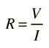

•

***SYMBOL:***

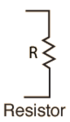

* ***CIRCUIT DIAGRAM:***

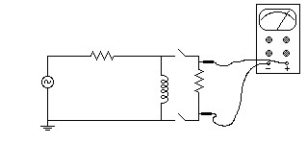

* ***SERIES CIRCUITS:***

***SERIES CIRCUITS DEFINED:***

*Two components are in series if they share a common node and if the* ***same current*** *flows through them.*

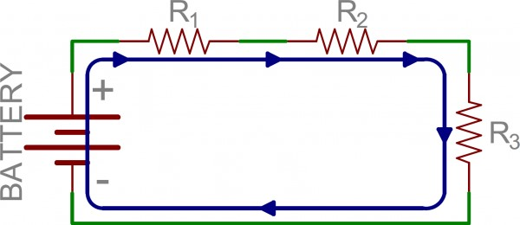

*There’s only one way for the current to flow in the above circuit. Starting from the positive terminal of the battery, current flow will first encounter R1. From there the current will flow straight to R2, then to R3, and finally back to the negative terminal of the battery. Note that there is only one path for current to follow. These components are in series.*

* ***PARALLEL CIRCUITS:***

*PARALLEL CIRCUITS DEFINED:*

*If components share two common nodes, they are in parallel. Here’s an example schematic of three resistors in parallel with a battery:*

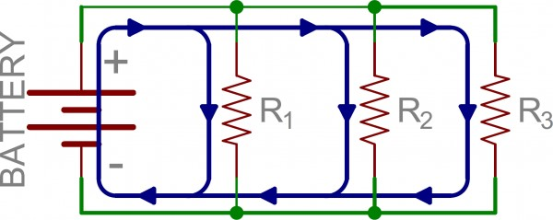

*From the positive battery terminal, current flows to R1… and R2, and R3. The node that connects the battery to R1 is also connected to the other resistors. The other ends of these resistors are similarly tied together, and then tied back to the negative terminal of the battery. There are three distinct paths that current can take before returning to the battery, and the associated resistors are said to be in parallel.*

*Where series components all have equal currents running through them, parallel components all have the same voltage drop across them.*

* ***OPEN AND SHORT CIRCUIT:***
* ***OPEN CIRCUIT:***

*An open circuit is a circuit where no current flows. Any circuit which a return path does not have is an open circuit. For example, if you connect wire to the two ends of a battery with a bulb in between, it glows as current flows in the wire because it has a return path or closed path. But, if you remove half part of the wire, then no current flows. Hence this becomes an open circuit.*

* ***SHORT CIRCUIT:***

*However, a short circuit is a circuit where the resistance is very low i.e. extremely high current flows. For example, if you connect the two ends of a battery directly by using a wire without any other components(like resistors) in between then it can be called a short circuit.*

***EXPERIMENTAL PROCEDURE:***

1. *Measure the resistance of the resistors available.*
2. *Then connect the combination of these resistors in parallel with the main circuit in order to drop the voltage to attain the desired voltage.*
3. *Then measure the value of voltage on PSPICE and after that implement it on breadboard.*
4. *Calculate the error.*

***PSPICE SIMULATION:***

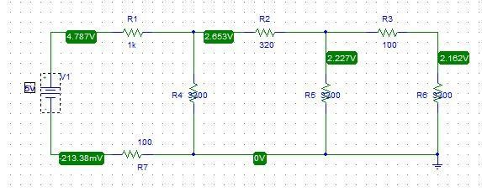

***OBSERVATIONS AND CALCULATIONS:***

|  |  |  |  |  |  |  |  |  |  |
| --- | --- | --- | --- | --- | --- | --- | --- | --- | --- |
| ***S.NO*** | ***Vs*** | ***R1*** | ***R2*** | ***R3*** | ***R4*** | ***R5*** | ***R6*** | ***R7*** | ***V AT R6*** |
| *1.* | *5V* | *1Kohm* | *320 ohm* | *100 ohm* | *3300 ohm* | *3300 ohm* | *3300 ohm* | *100 ohm* | *2.162V* |

➢ ***DATA ANALYSIS:***

1. *In ohm’s law, the value of current varying or increases as value of voltage varying or increases and vice versa.*
2. *In KVL, the resistance of resistor is high then voltage drop around this resistor is low and vice versa.*
3. *In KCL, current around series resistors are same and different around parallel resistor.*
4. *In KCL, voltage is different around series resistor and same around parallel resistor.*

➢ ***CONCLUSION:***

*Through this lab, I came to know about complex circuit and study how to analyze any complex circuit.*

**LAB RUBRICS: (Circuits & Systems-ILab)**

|  |  |  |  |  |
| --- | --- | --- | --- | --- |
| **Criteria & Point**  **Assigned** | **Outstanding** **4** | **Acceptable**  **3** | **Considerable**  **2** | **Below**  **Expectations**  **1** |
| **Attendance and**  **Attentiveness**  **in**  **Lab**  PLO10 | Attended in proper  Time and attentive  in Lab | Attended in proper Time but not attentive  in Lab | Attended late but attentive in Lab | Attended late not attentive in Lab |
| **Equipment /**  **Instruments**  **Selection and**  **Operation**  PLO1,  PLO2,  PLO3, PLO5, | Right selection and operation of appropriate equipment and instruments to perform experiment. | Right selection of appropriate equipment and instruments to perform experiment but with minor issues in operation | Needs guidance for right selection of appropriate equipment and instruments to perform experiment  and to overcome errors in operation | Cannot appropriately select  and operate  equipment and instruments to perform experiment. |
| **Result or**  **Output/**  **Completion of****target** **in Lab**  PLO9, | 100% target has been completed and well formatted. | 75% target has been completed and well formatted. | 50% target has been completed but not well formatted. | None of the outputs are correct |
| **Overall,**  **Knowledge**  PLO10, | Demonstrates excellent knowledge  of lab | Demonstrates good knowledge of lab | Has partial idea about the Lab and procedure  followed | Has poor idea about the Lab  and procedure  followed |
| **Attention to**  **Lab Report**  PLO4, | Submission of Lab  Report in Proper Time i.e. in next  day of lab., with proper documentation. | Submission of Lab Report in proper time but not with proper documentation. | Late Submission with proper documentation. | Late Submission  Very poor documentation |